Lab 1.04 - Magic Genie
Goal: Use Python to interact with variables and user input.
Type in the following code into a file and save:
a = input("What is your name? ")
# a = "cats and dogs"
# meow
print("Hello there, " + a)
- Read through the code and write down what you expect the printed results to be?
What is your name?
Hello there, kim

- Run the code and write down the actual printed result?
What is your name?
Hello there, kim

- Briefly describe what the # does?
# is a comment in python.

- Briefly describe what input does?
Input allows you to type in information needed. In this case, I type in my name so that it can reply back using my name.

Swapping
Copy the following code into your editor.
a = "this sentence should go second"
b = "this sentence should go first."
# your code starts here

# your code ends here
print(a)
print(b)
5. Run the program. What is the output?
this sentence should go second
this sentence should go first.

6. Write code to swap the values of variables a and b.
a = “this sentence should go second.”
b = “this sentence should go first”

print(b)
print(a)
Create a genie program. Save the file as magic_genie.py.
- Have the program introduce itself. Then have the program ask for three separate wishes. Finally, print all the wishes together.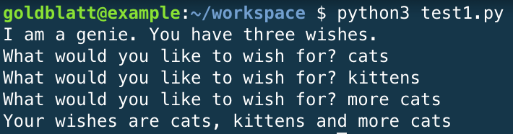

- There are some repeated strings in this genie program. Move those into variables.
- Now it's time to make your genie confused. Edit your code to have him print your first wish as your last wish, and your second wish as your first wish, and your third wish as your second wish.
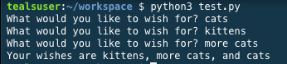

Hint!
Remember to add spaces you can combine " " to the end of your string using the + operator. So print("hello" + " " + "student") would print hello student
Collect user input by using:
n = input()
User input is collected at a String (str) So we must convert the type for its appropriate purpose.
int(input())
str(input())
magic_genie.py
global usrResp
def main():
print("I am a genie. You have 3 wishes.")
a = input("What would you like to wish for? ")
print(a)
b = input("What would you like to wish for? ")
print(b)
c = input("What would you like to wish for? ")
print(c)
print("Your wishes are " + b + ", " + c + ",and " + a + ".")
main()

